PROJECT REPORT
AGRIEDGE ORDER MANAGEMENT CRM

A Salesforce-Based Order Management and Automation System

SUBMITTED BY
PRIYANKA V

ARTIFICIAL INTELLIGENCE AND DATA SCIENCE

TECHNOLOGY STACK

Salesforce Developer Edition, Salesforce Object Manager, Process Builder, Apex Classes, Apex Triggers, Apex Test Classes, Developer Console, Salesforce CLI, and GitHub.

PROJECT OVERVIEW
AgriEdge Order Management CRM is a Salesforce-based solution developed to manage customer orders and related activities in the agricultural supply chain. The application provides a common platform for maintaining order details, managing order items, monitoring payments, and recording shipment information.

The system combines Salesforce custom objects with automation and Apex programming to support important business operations. It is designed to reduce repetitive administrative work, improve the accuracy of order information, and make order fulfillment easier to monitor. By connecting the major order-related records, the application provides users with a more organized way to manage business transactions.

OBJECTIVES

The main objectives of the project are:
- Automate Order Follow-Up: Generate follow-up tasks for newly created orders that satisfy the configured conditions.
- Improve Order Accuracy: Maintain consistent information about order items, quantities, prices, and order totals.
- Simplify Payment Monitoring: Maintain payment status information and support the configured processing of paid and failed orders.
- Organize Shipment Management: Associate shipment information with orders and maintain tracking details.
- Centralize Business Records: Store customer, order, inventory, and shipment information within Salesforce.
- Strengthen Data Security: Apply appropriate access permissions and validation rules.
- Support Business Monitoring: Use Salesforce reports and dashboards to review order-related activities.
- Improve Application Reliability: Test Apex classes and triggers to verify the expected behavior of the implemented logic.

KEY FEATURES

- Customized Salesforce application for agricultural order management.
- Centralized management of customer and order records.
- Automated follow-up task creation.
- Order item management and order total calculation.
- Payment status monitoring.
- Shipment record creation based on the configured payment condition.
- Order item cleanup for failed payments, if enabled in the implemented logic.
- Validation rules for selected business conditions.
- Security configuration and field history tracking, where enabled.
- Apex unit testing.
- Reports and dashboards for business monitoring.

PHASE 1: REQUIREMENT ANALYSIS AND PLANNING

UNDERSTANDING BUSINESS REQUIREMENTS
The project focuses on organizing order processing activities and reducing the effort required to maintain related business records. The main requirements identified for the application are described below.

A. Manual Follow-Up Tasks
Creating follow-up tasks manually for every new order can increase the workload of sales representatives and may result in missed activities.
Proposed Solution:
Configure Salesforce automation to invoke the OrderTaskCreator Apex class when a newly created order meets the specified entry condition. The class prepares a follow-up task associated with the relevant order.
B. Order Total Calculation Errors
Order totals may become inaccurate when quantities, prices, or order items change without updating the corresponding total.
Proposed Solution:
Use the configured formula fields or Apex automation to calculate the item totals and maintain the overall order amount. The calculation logic should reflect changes to the associated order items.

C. Delayed Shipment Processing
Shipment information may not be created promptly when payment verification and fulfillment activities are handled separately.
Proposed Solution:
Use the order trigger and its helper class to process qualifying payment status changes and create a shipment record when the payment status becomes Paid, according to the implemented business rules.

D. Inconsistent Order Information
Changes to orders, order items, and shipment details can result in inconsistent records when related updates are performed manually.
Proposed Solution:
Apply suitable validation rules, object relationships, and Apex automation to maintain consistency between related records.

E. Difficulties in Inventory Monitoring
Without organized stock information, users may find it difficult to identify products that require replenishment.
Proposed Solution:
Maintain inventory records containing stock quantities and reorder levels. These fields can support stock monitoring through the configured validation rules, reports, or other enabled automation.
PROJECT SCOPE
The project includes the following activities:
- Configuring a Salesforce development environment.
- Creating custom objects for orders, order items, inventory, and shipments.
- Using standard Account and Contact objects for customer information.
- Defining fields, relationships, and relevant picklist values.
- Configuring validation rules for selected business conditions.
- Developing Process Builder automation for follow-up task creation.
- Creating Apex classes and triggers for order-related processing.
- Supporting order total calculation through the configured logic.
- Creating shipment records following qualifying payment updates.
- Configuring the Salesforce Lightning application and page layouts.
- Setting up user permissions and field-level security.
- Testing the implemented Apex logic.
- Preparing reports and dashboards where configured.
- Maintaining documentation for deployment and future maintenance.

DATA MODEL DESIGN
The data model organizes the information required for managing orders and their related activities. Standard Salesforce objects are used for customer information, while custom objects store the application's order processing data.
OBJECT RELATIONSHIPS
Account: Maintains information about customers or business organizations.
Contact: Stores the contact information associated with customers.
AgriEdge Order:
Represents the main order record and maintains order status, payment status, customer information, and order amount.
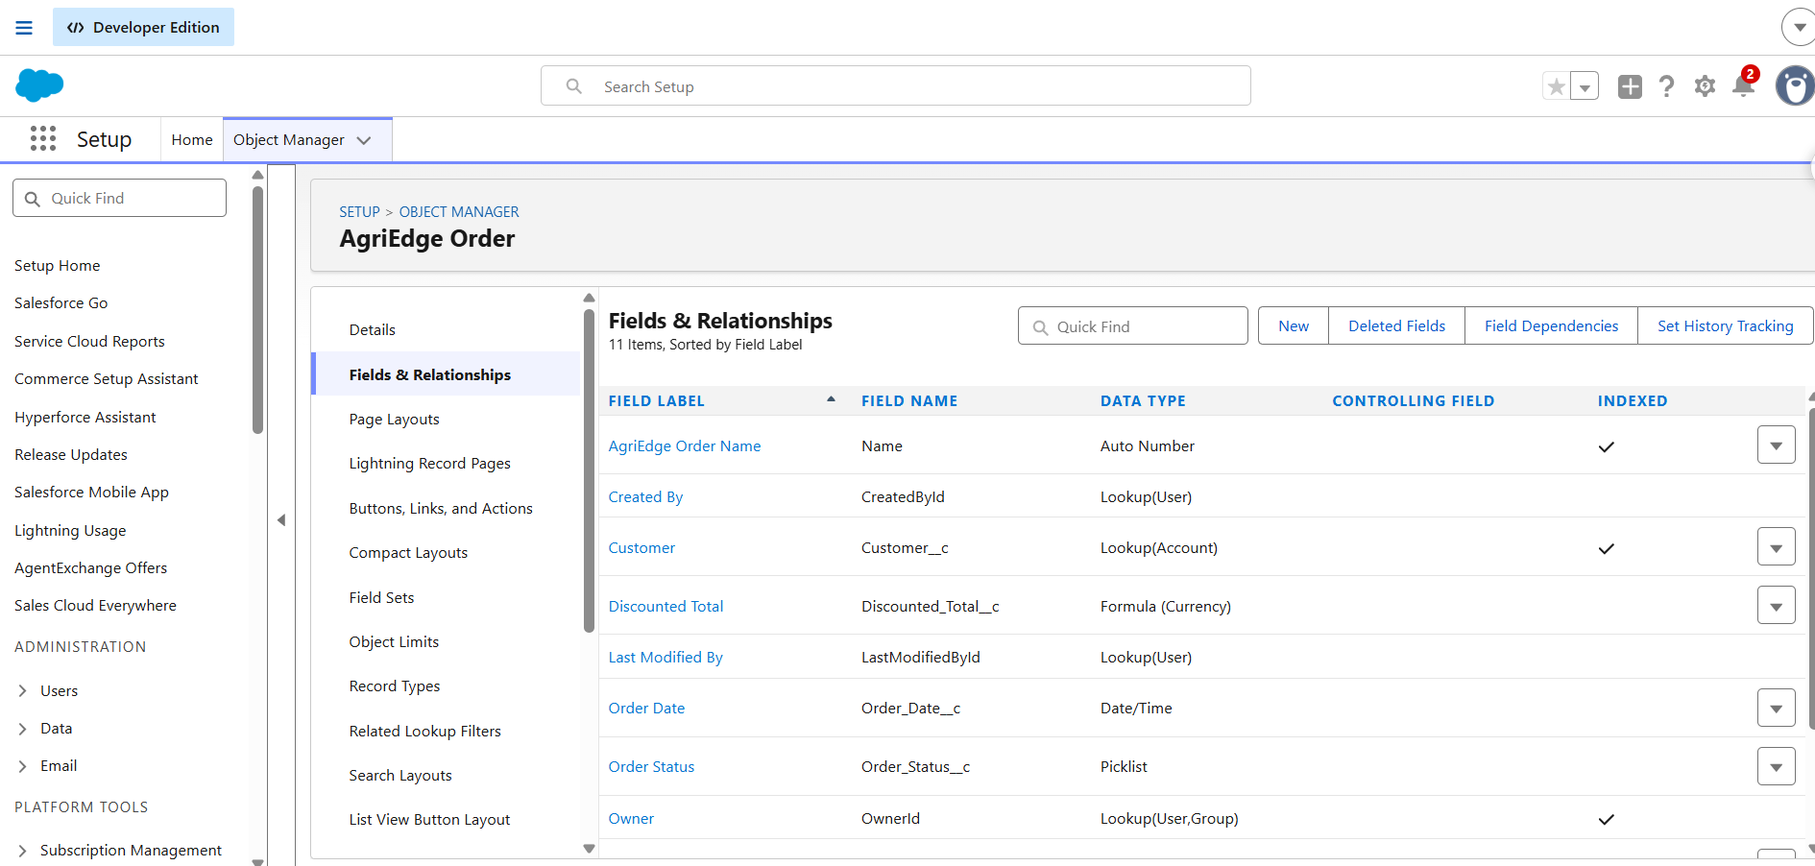

AgriEdge Order Item:
Stores the individual items associated with an order, including quantities and prices.

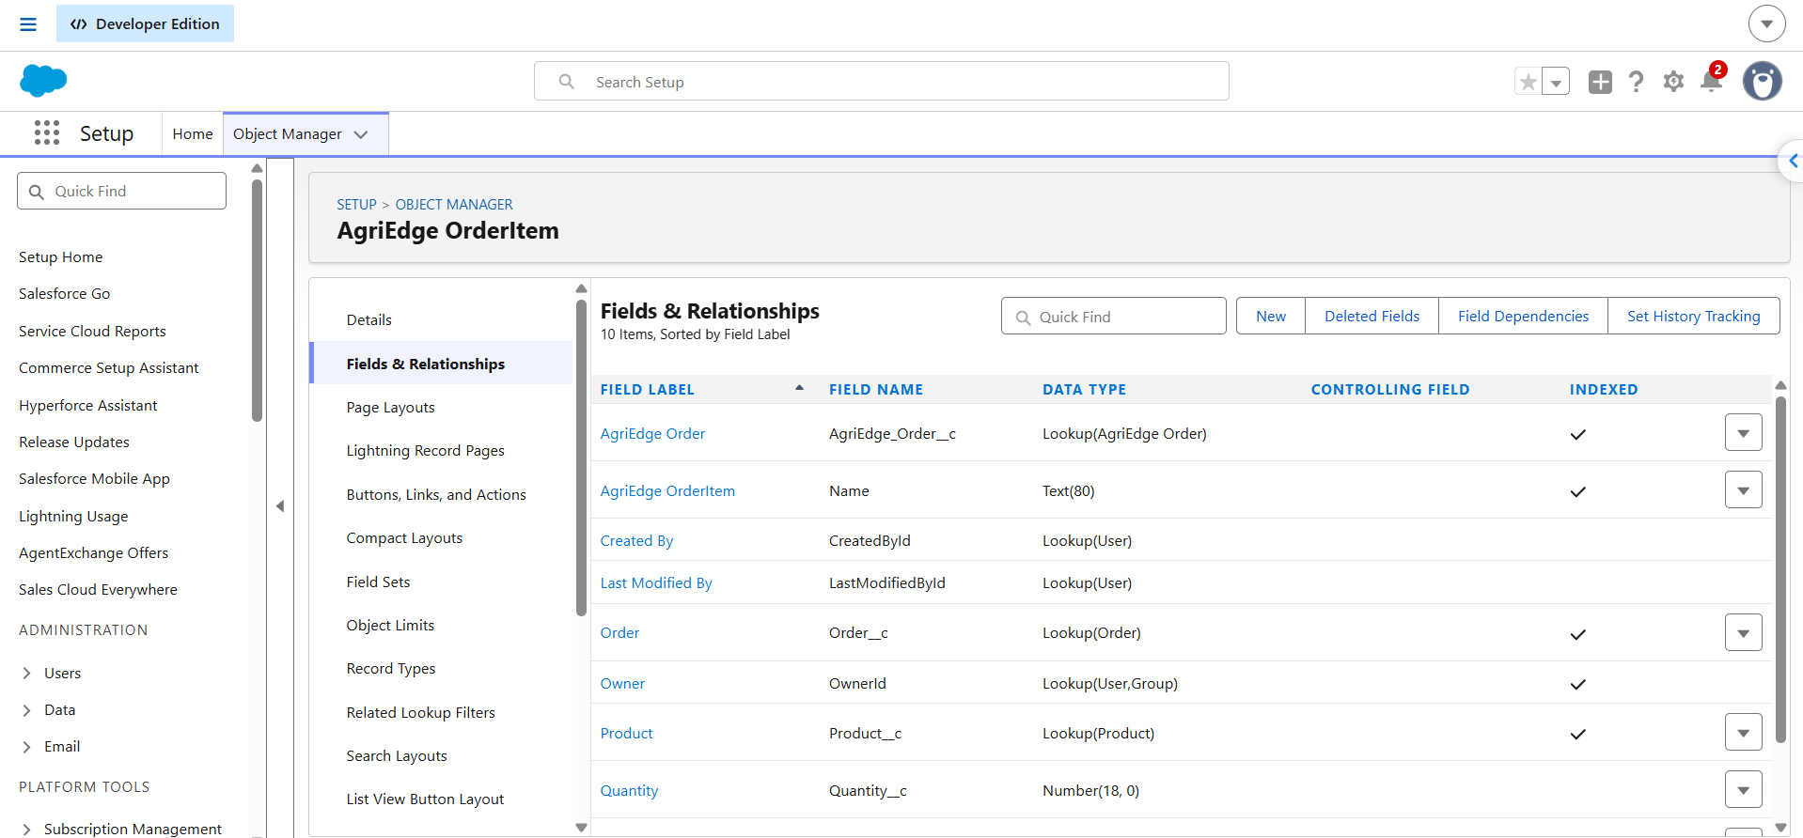

AgriEdge Inventory:
Maintains information about products, stock quantities, reorder levels, and storage locations.
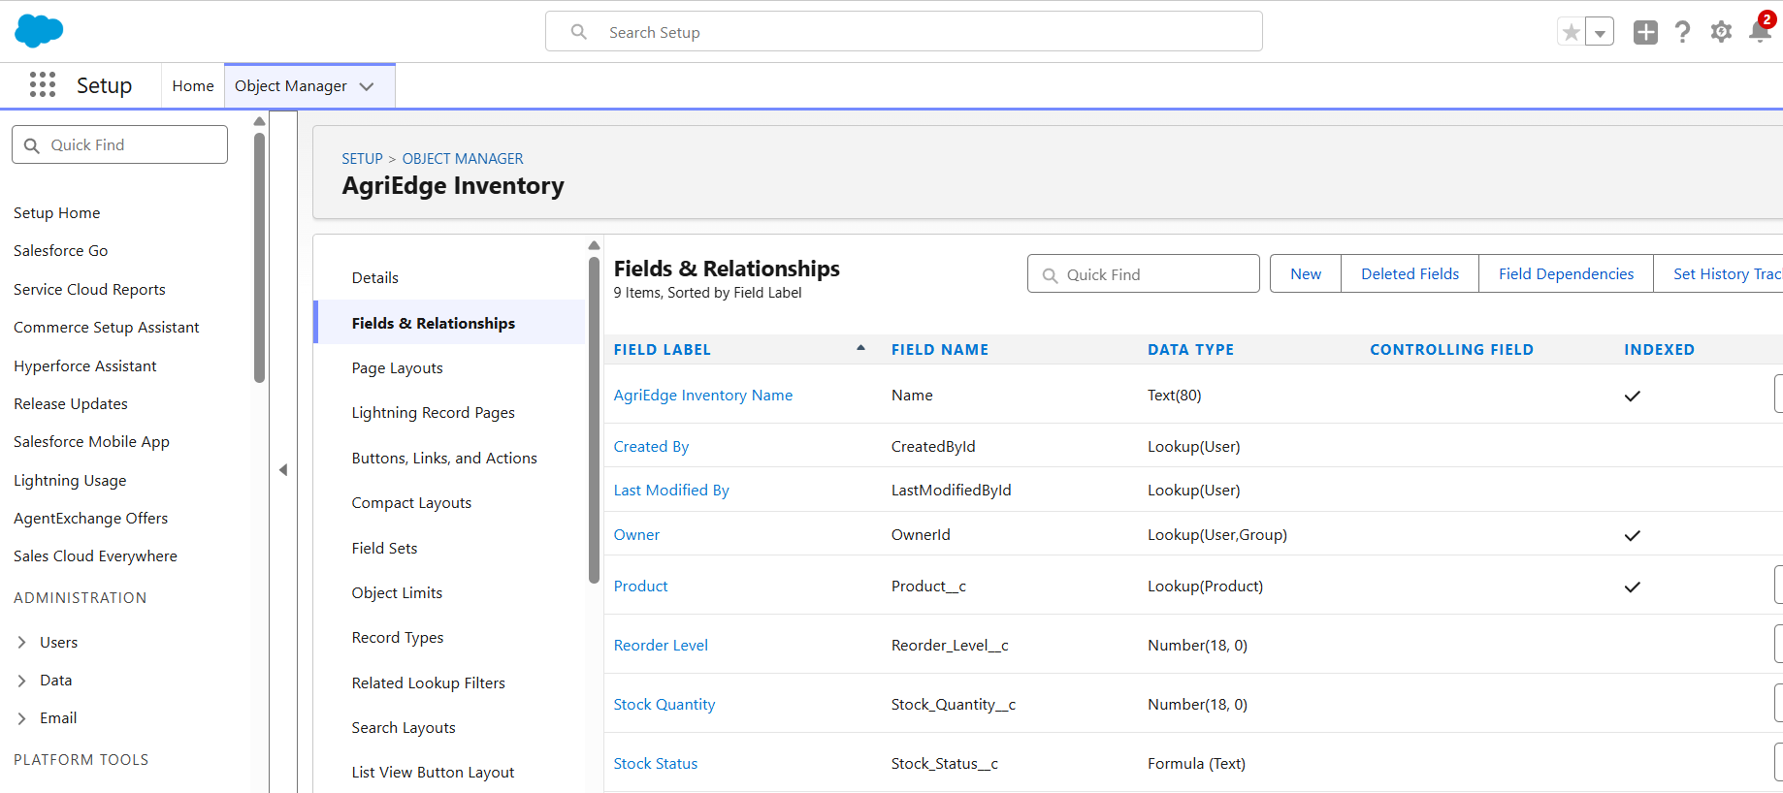

AgriEdge Shipment:
Stores shipment information associated with an order, including tracking and delivery details.

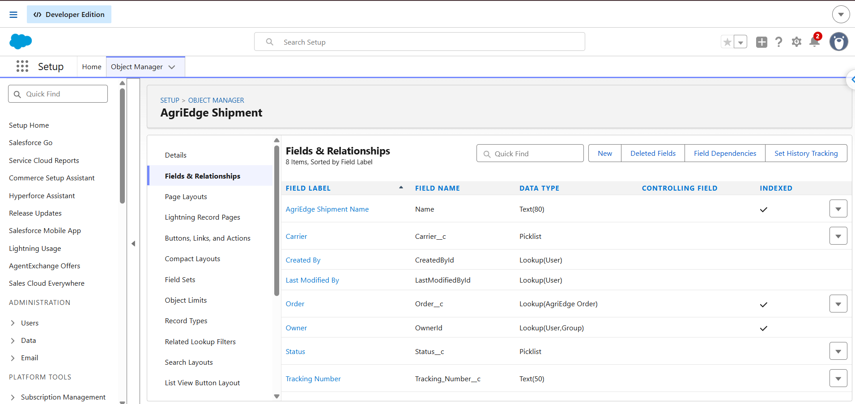

The relationships between these objects allow users to navigate from an order to its associated items and shipment records. The exact relationship types and field API names should match the configuration implemented in Salesforce.

DATA DICTIONARY
Important fields used by the application may include the following:
Object
  Field information
 | Order Name, Customer, Order Date, Order Status, Payment Status, Order Total
  AgriEdge Order
AgriEdge Order Item | Related Order, Product, Quantity, Unit Price, Item Total
AgriEdge Inventory | Product, Stock Quantity, Reorder Level, Warehouse Location
AgriEdge Shipment | Related Order, Tracking Number, Carrier, Shipment Status

ORDER STATUS VALUES
The order status field may use the following configured values:
- New
- Processing
- Shipped
- Delivered
- Cancelled
PAYMENT STATUS VALUES
The payment status field may use the following configured values:
- Pending
- Paid
- Failed
The available values should correspond to the picklist configuration in the Salesforce organization.

SECURITY MODEL DESIGN
Security configuration determines how users access customer information, orders, payment details, and shipment records.
PROFILES
Profiles define the baseline permissions assigned to Salesforce users. Administrative users require configuration permissions, while business users should receive only the access necessary for their responsibilities.
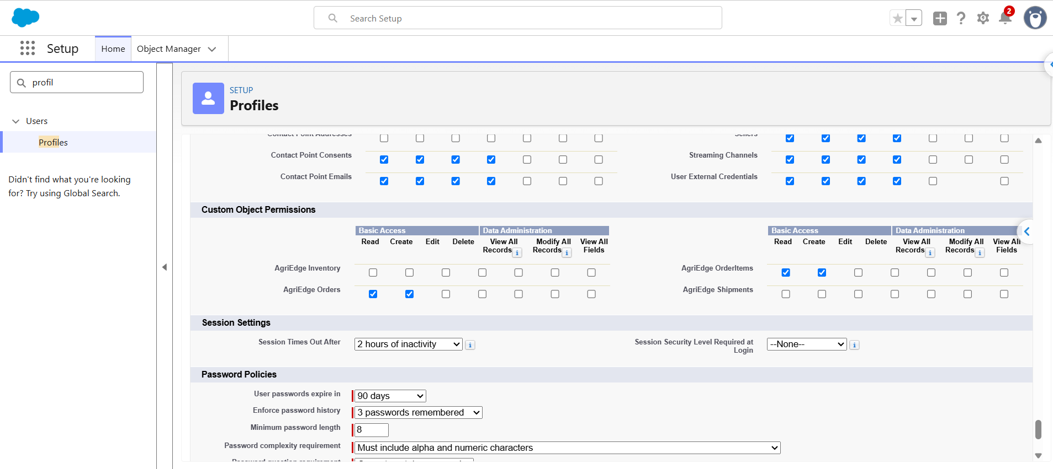
ROLE HIERARCHY
The project design identifies the following reporting structure:
- Sales Representative reports to CEO.
- Warehouse Manager reports to CEO.
- Finance Team reports to Sales Representative.
This hierarchy should reflect the actual Salesforce configuration and the organization's record visibility requirements.
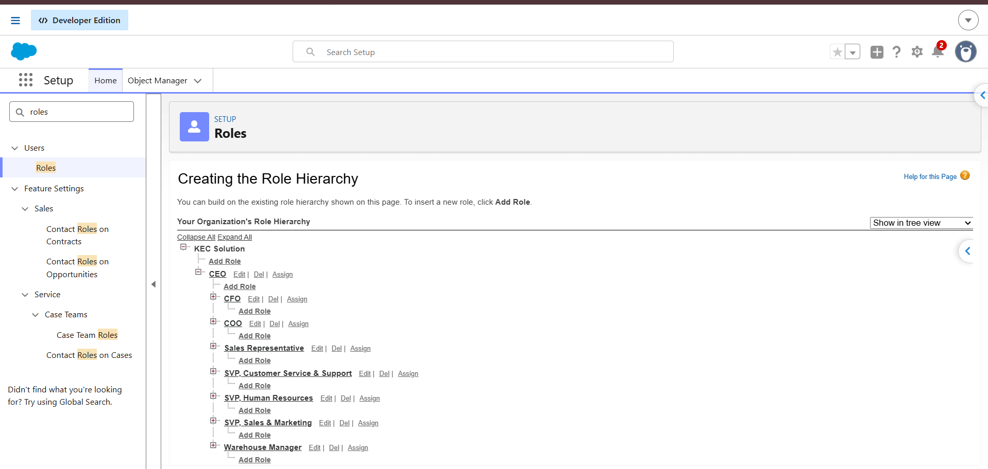
ORGANIZATION-WIDE DEFAULTS
Organization-wide defaults establish the baseline record access available to users. Account and order access should be configured according to the organization's data-sharing requirements. Child-record access depends on the relationship type and sharing configuration.
FIELD-LEVEL SECURITY
Field-level security can restrict editing of important fields, including Payment_Status__c and Order_Status__c, to authorized users. Object permissions and record-sharing settings should also be reviewed to ensure that the overall access model is appropriate.
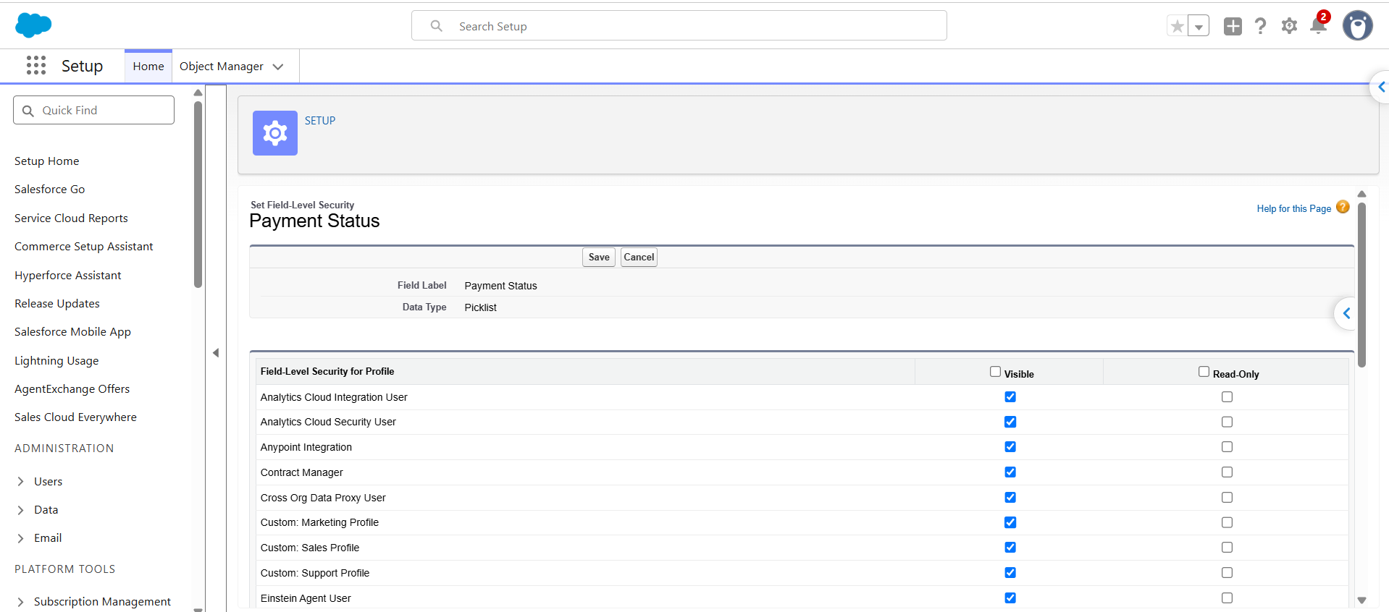

PHASE2: SALESFORCE DEVELOPMENT AND CONFIGURATION
The project uses Salesforce development tools and configuration features to implement its data model and automation logic.
The technology stack includes:
- Salesforce Developer Edition.
- Salesforce Object Manager.
- Salesforce Process Builder.
- Apex Classes and Apex Triggers.
- Apex Test Classes.
- Salesforce Developer Console.
- Salesforce CLI and GitHub, where used for source management.
These tools support object configuration, backend development, debugging, testing, and source-code maintenance.
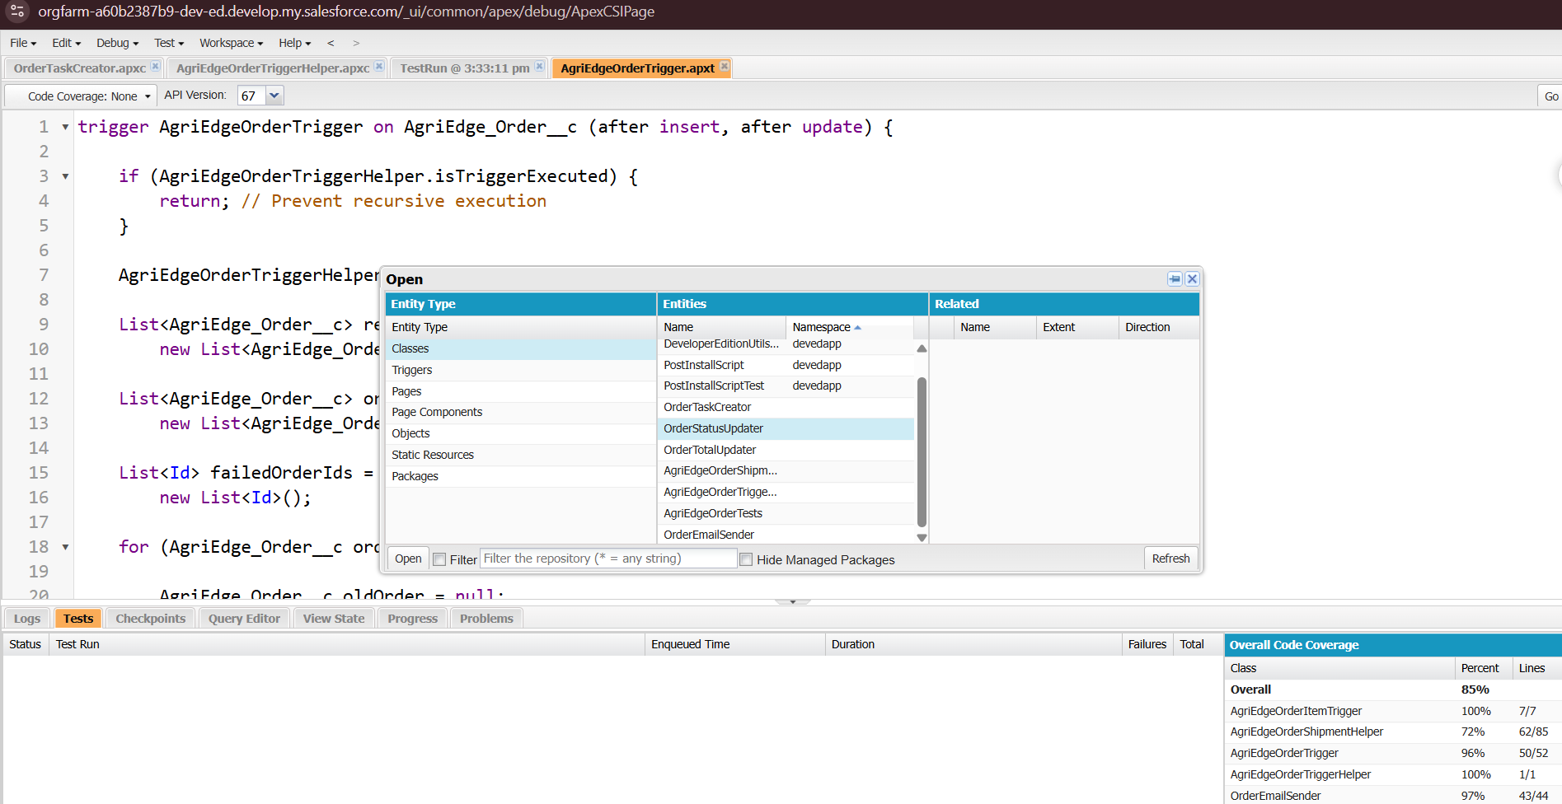

PROCESS BUILDER – ORDER TASK CREATOR
PURPOSE
The Order Task Creator automation is designed to generate a follow-up task when a new AgriEdge Order satisfies the configured conditions.
CONFIGURATION
Process Name: Order Task Creator
Object: AgriEdge_Order__c
Trigger: When a record is created.
Entry Condition: Order Status equals New.
Action: Invoke the OrderTaskCreator Apex method.
EXPECTED RESULT
When a qualifying order is created, Salesforce invokes the Apex method to prepare a follow-up task for the order owner.
The task configuration includes:
- Subject: Follow up on New Order
- Status: Not Started
- Priority: High
- Related Record: AgriEdge Order
This process reduces the need for users to create identical follow-up tasks manually. The actual result depends on the active automation configuration and the Apex implementation.
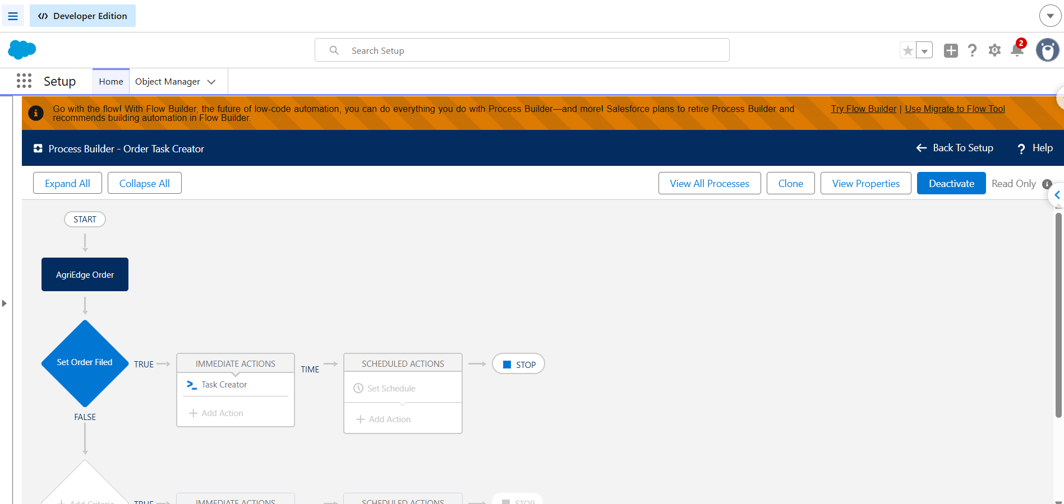

APEX DEVELOPMENT
Apex is used to implement the server-side logic that supports order processing. The project's main components are OrderTaskCreator, AgriEdgeOrderTrigger, and AgriEdgeOrderShipmentHelper.
INVOCABLE APEX CLASS – OrderTaskCreator
Purpose: Creates follow-up tasks for newly created orders.
File Name: OrderTaskCreator.cls
The class receives order record IDs from Salesforce automation and retrieves the corresponding order information. It then prepares Task records using the configured subject, status, priority, owner, and order relationship.
Working Principle:
- Receives order IDs from the automation process.
- Retrieves the relevant order records.
- Prepares follow-up task records.
- Assigns the tasks to the corresponding order owners.
- Inserts the prepared tasks into Salesforce.
The existing Apex code should be retained if it represents the implementation in the Salesforce organization.
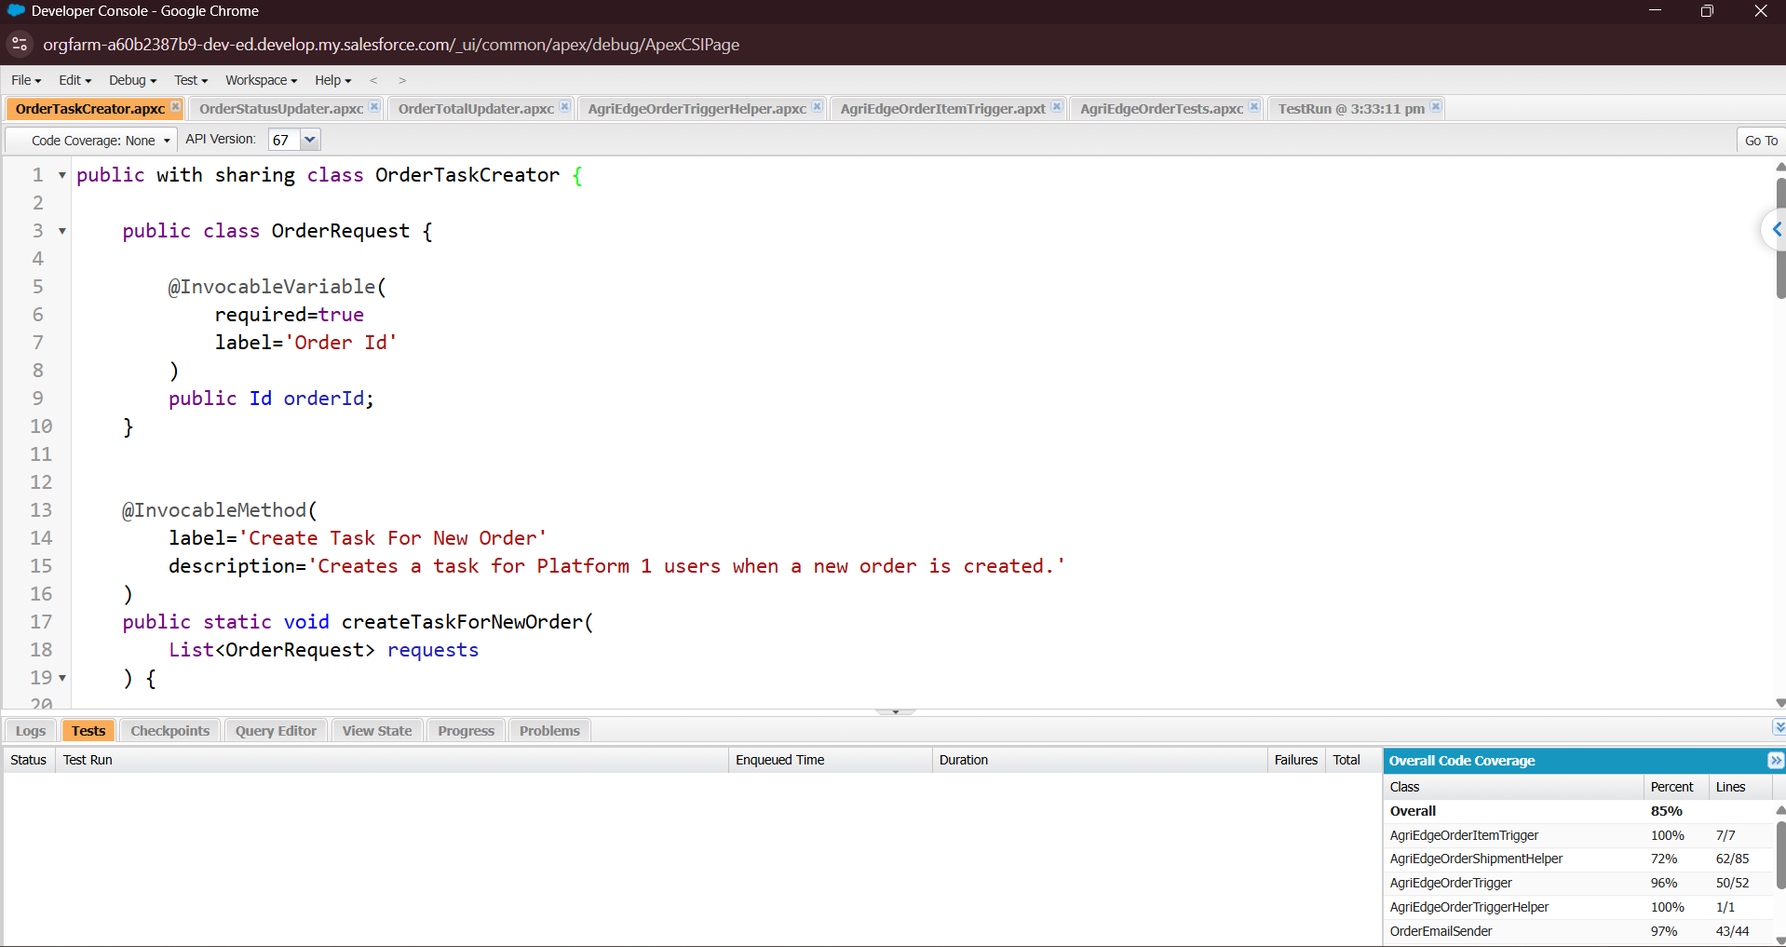
APEX TRIGGER – AgriEdgeOrderTrigger
Purpose: Identifies relevant changes to order and payment status fields.
File Name: AgriEdgeOrderTrigger.trigger
The trigger executes after an order record is updated. It compares the new record values with the previous values to determine whether the fields relevant to order processing have changed.
When a relevant update is detected, the trigger passes the affected records to the AgriEdgeOrderShipmentHelper class.
Working Principle:
- Executes after an order update.
- Retrieves the previous version of each affected record.
- Checks for changes in order status or payment status.
- Collects records that require further processing.
- Invokes the helper class for the relevant records.
The trigger and helper class should be tested together to confirm that unrelated updates do not cause unintended shipment creation or record deletion.
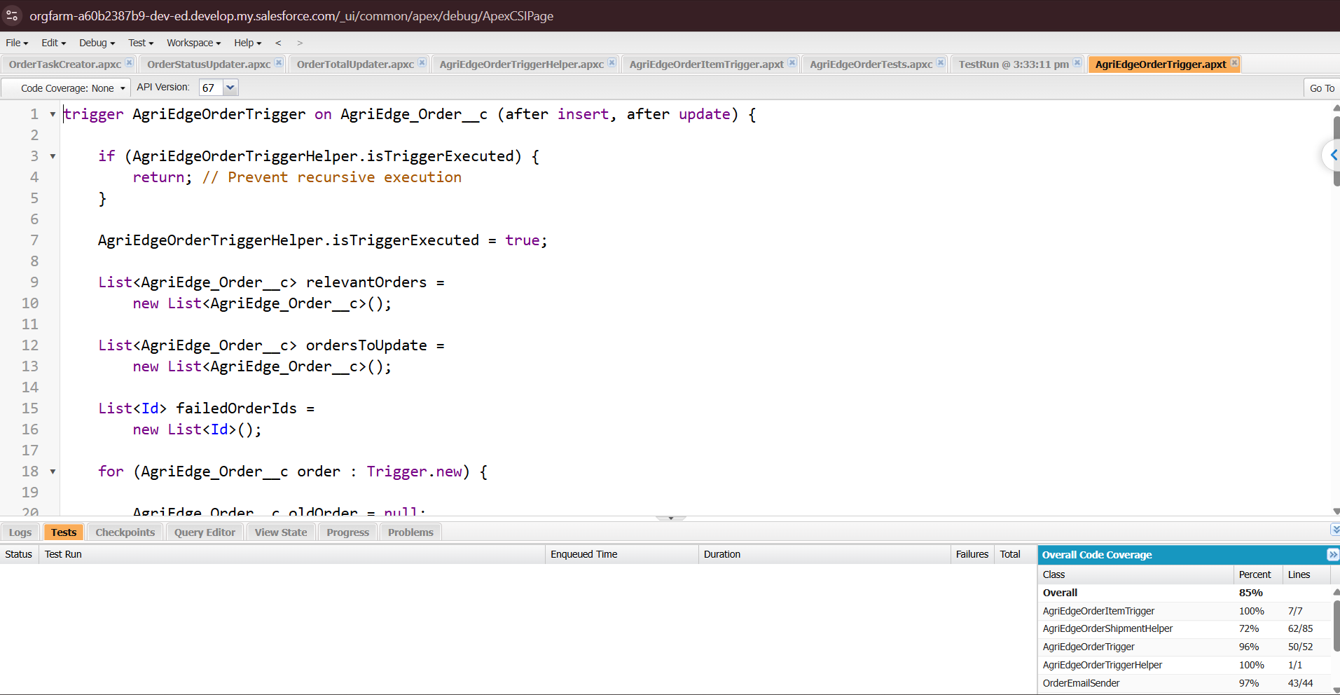

HELPER CLASS – AgriEdgeOrderShipmentHelper
Purpose: Supports shipment creation and the configured processing of orders with failed payments.
File Name: AgriEdgeOrderShipmentHelper.cls
The helper class receives the relevant order records from the trigger and processes them according to their payment status.
Successful Payment:
When an order's payment status becomes Paid, the helper class can prepare a related shipment record and assign a tracking number using the implemented logic.
Failed Payment:
When an order's payment status becomes Failed, the helper class identifies associated order items for the configured cleanup operation.
Working Principle:
- Receives the relevant order records.
- Identifies orders with a qualifying Paid status.
- Prepares shipment records for those orders.
- Generates tracking numbers using the implemented method.
- Identifies failed-payment orders.
- Performs the configured cleanup on the associated order items.
The code should be checked to ensure that shipments are not duplicated and that cleanup affects only the intended records.
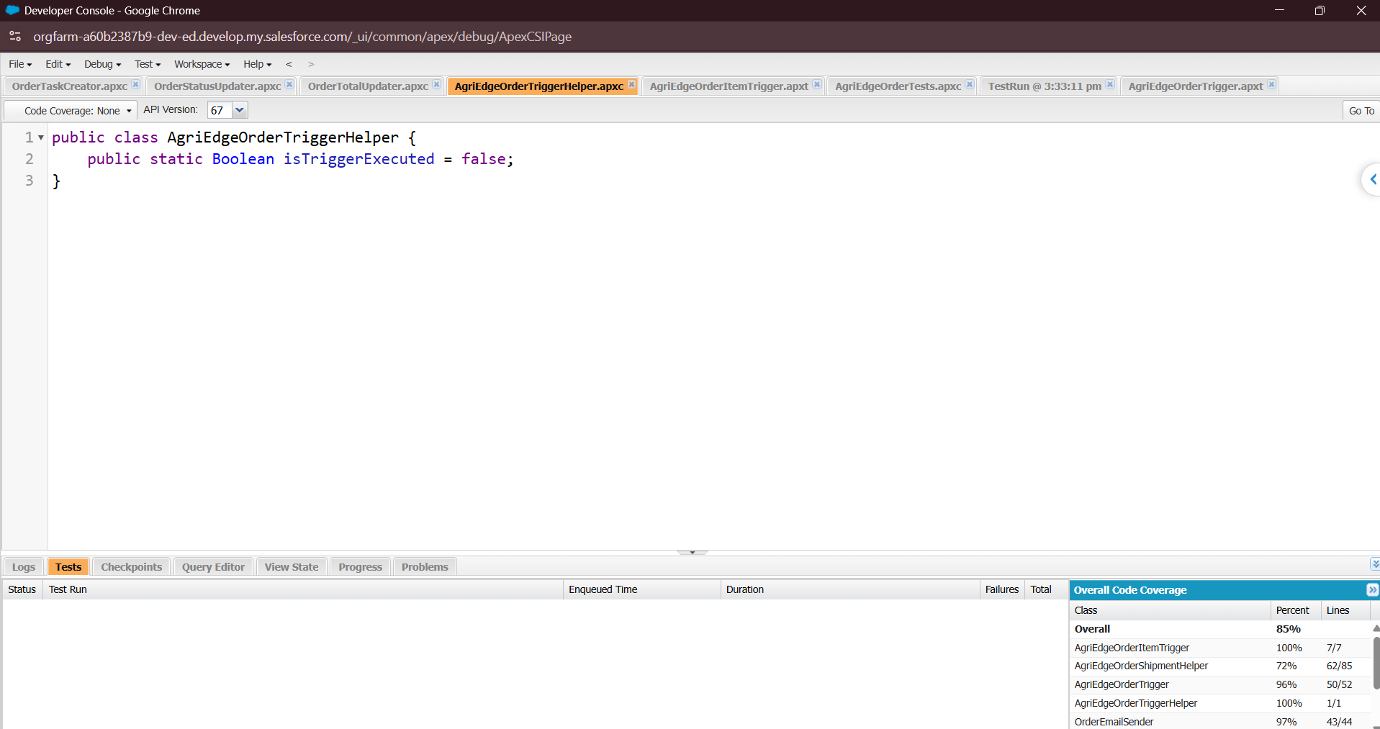

PHASE 3: UI/UX DEVELOPMENT AND CUSTOMIZATION
LIGHTNING APPLICATION CREATION
A custom Salesforce Lightning application named AgriEdge is intended to provide a centralized interface for accessing order management features.
The application groups the main business objects and reporting pages into a common navigation area.
APPLICATION NAVIGATION
The navigation menu may include the following items, depending on the configured application:
- Accounts
- Contacts
- AgriEdge Orders
- AgriEdge Order Items
- AgriEdge Inventory
- AgriEdge Shipments
- Reports
- Dashboards
This arrangement helps users access the records required for their daily activities without navigating through unrelated Salesforce modules.
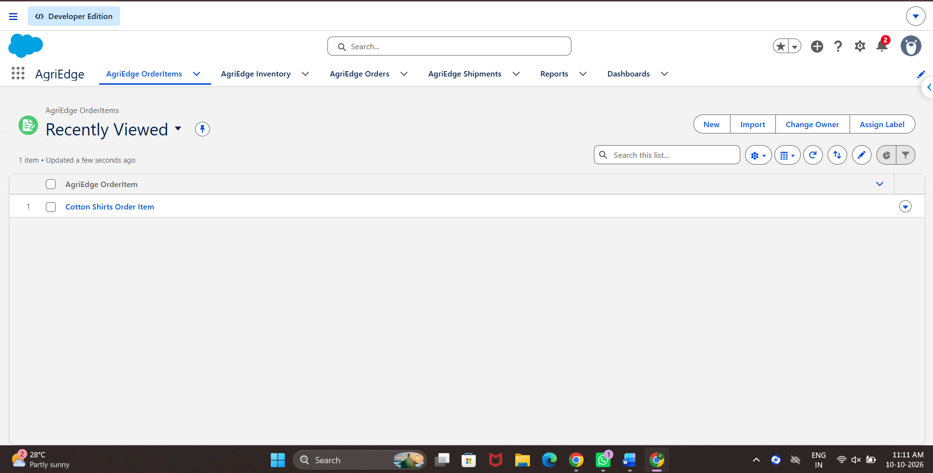
PAGE LAYOUT CUSTOMIZATION
The AgriEdge Order page layout organizes order information into meaningful sections.
ORDER INFORMATION
- Order Name
- Customer
- Order Date
- Order Status
FINANCIAL INFORMATION
- Payment Status
- Order Items
- Order Total, if configured
FULFILLMENT TRACKING
- Shipment Details
- Tracking Number
- Shipment Status
These sections improve the readability of order records and make related information easier to locate. The final layout should match the actual Salesforce page configuration.
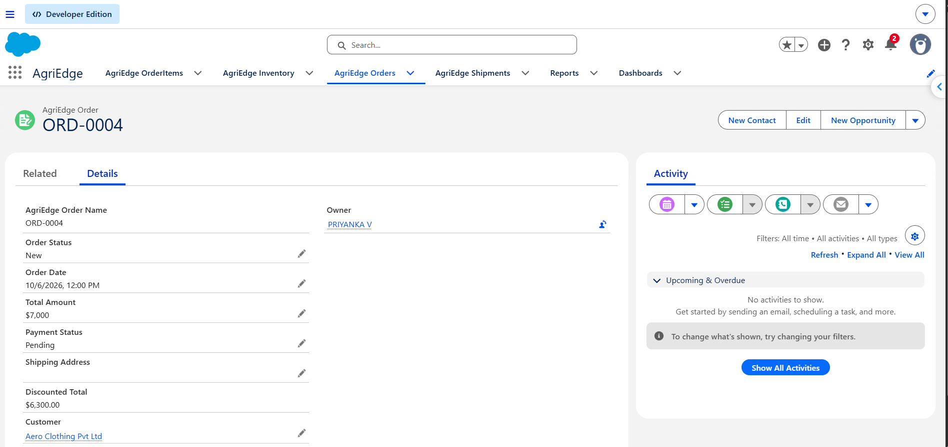

PHASE 4 – DATA MIGRATION, TESTING AND SECURITY
DATA MIGRATION
Sample customer and related business information can be imported into Salesforce using the Data Import Wizard or another suitable import method.

DATA IMPORT PROCESS
- Prepare the required source data in CSV format.
- Select the Salesforce object that will receive the data.
- Map the source columns to the appropriate Salesforce fields.
- Check required fields and relationship references.
- Import the records.
- Review any failed records or import errors.
- Verify that the imported information is accurate.
Account and Contact records should be available before importing dependent records that reference them. If the project uses manually created sample data rather than an import process, the documentation should state that accurately.
SECURITY CONFIGURATION
FIELD HISTORY TRACKING
Field history tracking can be enabled for important fields such as:
- Order_Status__c
- Payment_Status__c
This feature helps authorized users review changes to selected fields. The final report should identify only the fields for which history tracking is actually enabled.

DUPLICATE MANAGEMENT
Matching Rules and Duplicate Rules can help identify repeated customer or contact records. Matching Rules define how records are compared, while Duplicate Rules determine whether Salesforce warns users about or blocks potential duplicates.
These features should be documented as implemented only if the corresponding rules have been configured and activated.

ACCESS CONTROL
Access to the application is managed through profiles, permissions, field-level security, roles, and record-sharing settings.
The configuration should ensure that users can access the records and fields required for their responsibilities while restricting unauthorized changes to important business information.
VALIDATION RULES AND ERROR HANDLING
Validation rules are implemented in Salesforce to ensure that users enter valid and consistent data when creating or updating order records. When the configured validation conditions are not satisfied, Salesforce displays an error message and prevents the record from being saved. These validations help maintain data accuracy in the AgriEdge Order Management CRM system.

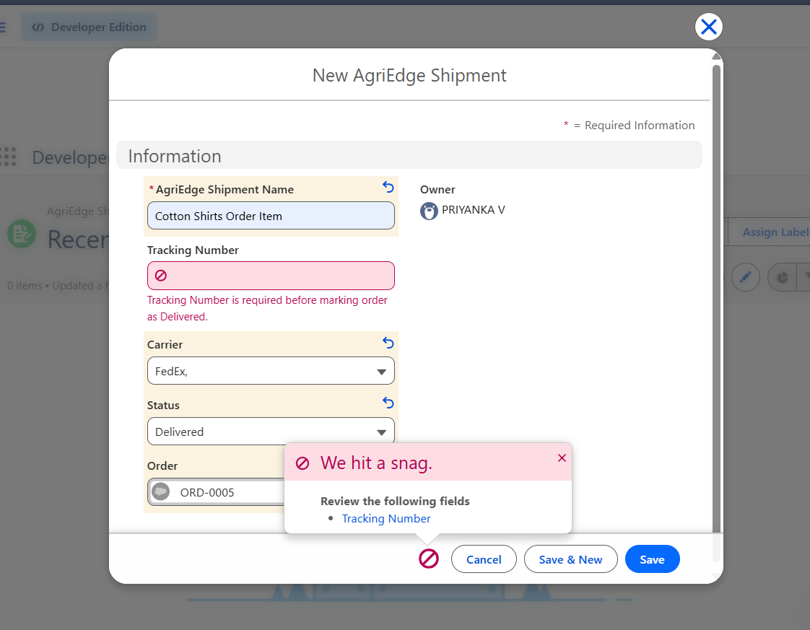
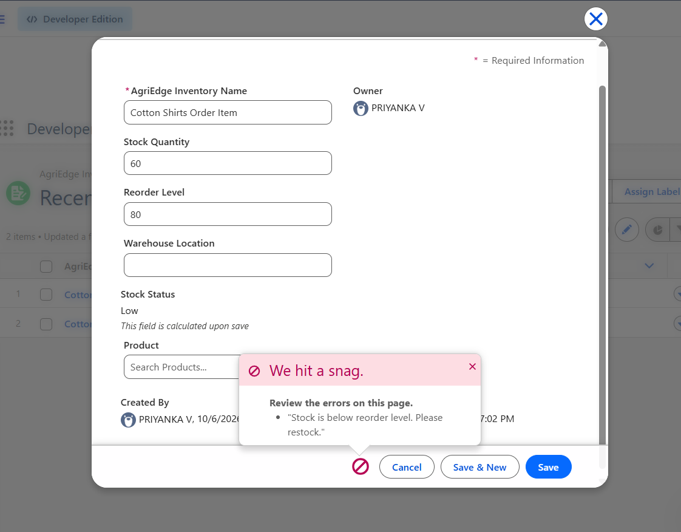

UNIT TESTING
Apex test classes are used to verify the behavior of the project's backend components.
Test Class: AgriEdgeOrderTriggerTest.cls
The test suite should verify order processing, follow-up task creation, shipment handling, and failed-payment behavior according to the implemented code.

TEST CASES

Test case | Expected result
 | The order record is saved with valid information.
  Create a new order
  Trigger follow-up automation
  A task is created for qualifying new order
Update order status | The configured trigger logic responds to relevant status changes.
  Mark payment as Paid
  The configured shipment processing runs as expected.
 | The configured failed-payment behavior is executed.
  Mark payment as Failed
Test validation rules
  Invalid records are rejected when an active rule applies.
Test record permissions
  Users can perform authorized actions and are restricted from unauthorized ones.
Verify reports | Report results correspond to the available records and user access.

TEST EXECUTION RESULTS
The final report should include the actual results returned by Salesforce after running the Apex test suite. The number of tests passed, failed tests, and code coverage should be recorded from the Developer Console or the relevant Salesforce testing interface.
A successful test pass rate does not automatically indicate complete Apex code coverage. Both values should be reported separately.
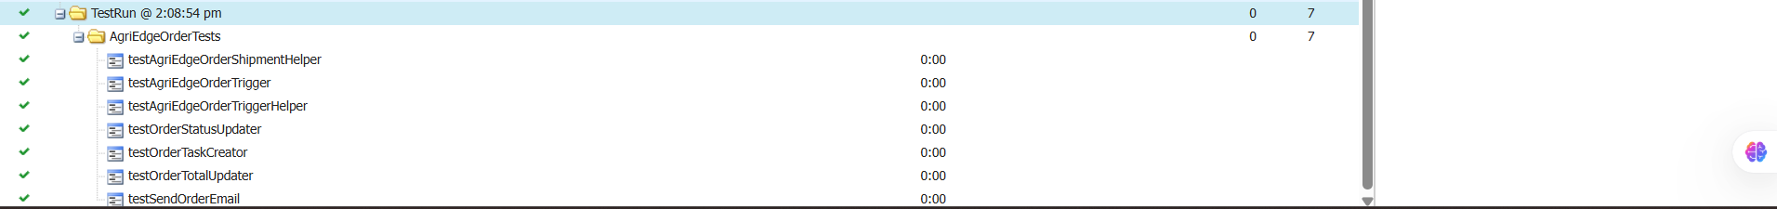
PHASE 5 – DEPLOYMENT , MAINTENANCE AND TROUBLESHOOTING
DEPLOYMENT STRATEGY
The application can be moved from the development environment to the target environment using an appropriate Salesforce deployment method, such as Change Sets or Salesforce CLI.
The deployment should include the metadata required by the project, including custom objects, fields, Apex classes, triggers, test classes, page layouts, and automation components.
DEPLOYMENT ACTIVITIES
- Review the completed configuration and Apex source code.
- Run the required Apex tests.
- Validate the deployment package.
- Deploy the approved components to the target environment.
- Confirm that the required permissions and automation settings are available.
- Verify the major order processing functions after deployment.
- Record deployment issues and their resolutions.
The final documentation should state the deployment method actually used.
SYSTEM MAINTENANCE
Regular maintenance helps keep the Salesforce application reliable and aligned with business requirements.
The main activities include:
- Reviewing Apex test results after code changes.
- Checking debug logs when errors occur.
- Monitoring automation failures.
- Reviewing user access and permissions.
- Checking order and payment status consistency.
- Confirming that shipment records are correctly associated with orders.
- Reviewing report and dashboard results.
- Maintaining source files and documentation.
TROUBLESHOOTING
When a problem occurs, the relevant Salesforce component should be identified before making changes.
- Review the error message and identify the affected object or automation.
- Check field API names, relationship references, and picklist values.
- Inspect debug logs and automation error details.
- Verify that the running user has the required permissions.
- Reproduce the issue using appropriate test records.
- Correct the identified cause and rerun the relevant tests.

CONCLUSION
The AgriEdge Order Management CRM demonstrates how Salesforce can be used to organize customer orders and related agricultural supply chain activities. The application brings together customer information, order items, inventory details, payment status, and shipment records within a centralized CRM environment.
The project uses Salesforce configuration and Apex programming to support follow-up task creation and order-related processing. Security settings, validation rules, and unit testing help maintain data consistency and verify the expected behavior of the application.
By reducing selected manual activities and improving access to order information, the system provides a foundation for more organized order management. Additional capabilities such as AI-based insights, customer order tracking, automated notifications, and advanced reporting could further improve the application in future versions.

